Reporting
Rome Statute
Offences to the ICC

- Estimate which statutes the crime violates.
- Read https://rinj.org/war-crime/
- Read appropriate https://rinj.org/documents/
- Complete a RINJ Foundation Sexual Assault Universal Crime Report
- Escalate to Section Head

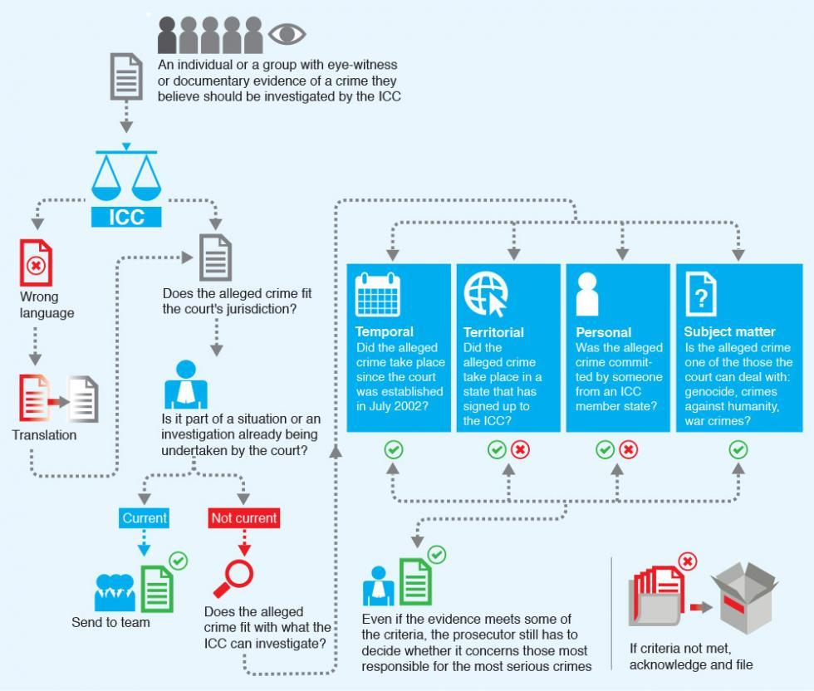

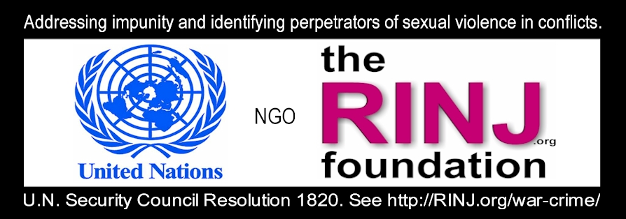

Source: Emeric Rogier, Head of Situation Analysis at the ICC.
Q: Can anyone send a complaint to the ICC?
A: Yes, any individual, group or organisation can send information on alleged crimes to the Office of the Prosecutor (OTP) of the ICC. These are referred to as “communications.” They can be sent by post, by fax or by e-mail to otp.informationdesk@icc-cpi.int. Because all communications are subjected to analysis by the OTP, the more detailed and substantive the information received, the better the Office is able to focus its analysis.
Q: What language can a sender use?
A: Senders are advised to submit information in English or French (the working languages of the Court) or in one of the other official languages of the Court: Arabic, Chinese, Russian and Spanish. If the information is submitted in another language, the Office attempts to obtain informal translations where possible.
Q: What do you do when you get a complaint?
A: Upon receiving a communication, the Office assesses whether the allegations appear to fall within the Court’s jurisdiction. The jurisdictional criteria are explained further below. If the communication does not appear to meet the jurisdictional criteria, it is deemed to be manifestly outside of the Court’s jurisdiction. If the criteria appear to be met, a communication can be linked to a situation that is already under investigation or preliminary examination by the Court, in which case it is analysed as part of those situations and cases, by the relevant investigative team.
Q: But what if the communication isn’t about a situation already under investigation?
A: If the communication does not relate to any situation under investigation or preliminary examination, it will be deemed as warranting further analysis in order to inform a decision on whether a formal preliminary examination should be initiated. This decision is made on the basis of all communications relating to the same situation, as well as publicly available information. Communications are not analysed in isolation from each other.
Q: Do you let the sender know what’s happening?
A: In all cases, the sender is informed by the OTP Information Desk of which of the above ways his/her communication will be dealt with by the Office. The sender also receives an individual reference number, so that they can submit additional information as part of the communication should he/she wish to do so.
Q: How many different countries do you get complaints from?
A: We receive communications from nearly every country in the world. To date, the Office has received over 10,000 different communications, all of which have been analysed to determine whether the allegations fall within the Court’s jurisdiction. From 1 November 2013 to 31 October 2014, the OTP received 579 communications relating to over 100 different countries, both states parties and non-states parties. Of these, 462 were manifestly outside the Court’s jurisdiction, 44 warranted further analysis, 49 were linked to a situation already under analysis, and 24 were linked to an investigation or prosecution.
Q: How does the ICC decide which cases to take on?
A: While the Office is open to all referrals and communications, the decision on whether to initiate an investigation on the basis of such referrals or communications, as well as the selection of cases within a situation, is for the Prosecutor to decide. The criteria applied by the Prosecutor in deciding whether to initiate an investigation are set forth in the Rome Statute and are applied equally to all situations, irrespective of whether the situation has been the subject of a referral or the Prosecutor is acting on the basis of communications received.
Q: How does she make that decision?
A: The Prosecutor’s independent role in selecting situations and cases helps to ensure that the impartiality of the ICC is preserved. The OTP applies consistent methods and criteria, irrespective of the States or parties involved or the person(s) or group(s) concerned. For instance, geopolitical implications, or geographical balance between situations, are not relevant criteria for the Prosecutor’s selection of situations and cases. The Prosecutor has adopted a strategy of investigating and prosecuting those who bear the greatest responsibility for the most serious crimes within a situation, based on the evidence that emerges in the course of an investigation.
Q: How do you decide whether the information is about crimes that fall under the ICC's mandate?
A: The Office assesses the time period of the alleged crimes (temporal jurisdiction), where or by whom the alleged crimes were committed (territorial or personal jurisdiction), as well as the nature of the crimes alleged (subject-matter jurisdiction). Only crimes committed after the Rome Statute (the international treaty establishing the ICC) entered into force in a given country can be considered. For many states, this will be from 1 July 2002 onwards, but it can be later depending on when that state became a party to the Statute. In addition, the alleged crimes must have been committed either on the territory of, or by the national of, a state which has accepted the Court’s jurisdiction. The only exception to this rule is if the UN Security Council has referred a situation to the Court. Finally, the ICC has jurisdiction over only three international crimes: genocide, crimes against humanity, and war crimes. Therefore, an ‘ordinary’ crime which does not appear to qualify as any of the above crimes would not fall within the ICC’s jurisdiction.
In sum, alleged crimes committed before 2002, or on the territory of a country that is not an ICC member, or allegations of ‘ordinary’ crimes, will usually be dismissed by the Office for falling outside of the Court’s jurisdiction.
In addition, the OTP is also required to consider whether national systems are investigating and prosecuting the relevant crimes, the gravity of the crimes, and the interests of justice.
Q: How would a complaint received from an individual ever end up forming part of a case?
A: Information received by the Office on alleged crimes is analysed in conjunction with other relevant communications as well as open source information. In other words, communications are not analysed in isolation from each other, but rather are used to inform the Office’s analysis of a situation as a whole. If a communication that is deemed to warrant further analysis does not relate to any situation that is already under investigation or preliminary examination, then it will be analysed with the assistance of other related communications and other available information in order to inform a decision on whether a formal preliminary examination should be initiated.
If a communication is received that relates to a situation that is already under investigation or preliminary examination, that communication will be channelled to the appropriate team within the Office working on that situation or case. Whether that information is presented as evidence in trial or pre-trial proceedings will depend on a number of prosecutorial considerations, primarily the relevance and strength of the evidence.
Q: What kinds of cases can be officially referred to the ICC?
A: Any situation in which one or more crimes within the jurisdiction of the Court appear to have been committed can be referred to the Prosecutor of the ICC.
Q: Who can do that?
A: Referrals can be made either by a State Party to the Rome Statute or by the United Nations Security Council.
Q: How can they do that?
A: Referrals must be made in writing and sent to the Prosecutor of the ICC.
Q: If member states can refer cases, how can information from non-member states or individuals ever be used?
A: The criteria for the selection of situations and cases by the Prosecutor are the same, irrespective of whether or not there has been a referral. The Prosecutor has been granted statutory powers to independently initiate an investigation on the basis of information received on alleged crimes. This information can be sent by any individual, group or organisation. Once received, the information is analysed using the criteria described above (jurisdiction, admissibility and the interests of justice). For the Prosecutor to proceed with an investigation on this basis, she must apply to a Pre-Trial Chamber for authorisation to investigate. To date, the Prosecutor has done so twice: in Kenya (2009) and in Côte d’Ivoire (2011).

