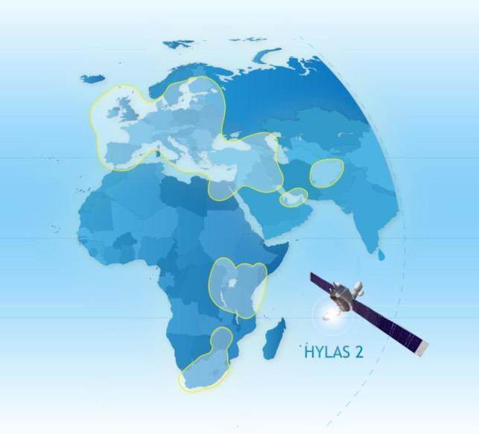

Hardware Complete Systems (Hughes HN9260) – With 74 Cms Dish – US$ 325
- Hardware Complete systems (NEWTEC)– With 78 Cms Dish and 2 WATTs BUC -- $ 450

Service Plans | Download Speed (Kbps)* | Upload Speed (Kbps)* | Monthly volume allowance (GB)** | Cost Per Month(US$) | Preferred  Device
Consumer 12 | 1024 | 256 | 12 | 85 | HN 9260 and NEWTEC
Consumer 18 | 2048 | 512 | 18 | 110 | HN 9260 and NEWTEC
Consumer 26 | 2048 | 768 | 26 | 145 | HN 9260 and NEWTEC
Consumer 35 | 3072 | 768 | 35 | 190 | HN 9260 and NEWTEC
Consumer 40 | 3072 | 768 | 40 | 220 | HN 9260 and NEWTEC
Prosumer 50 | 4096 | 768 | 50 | 260 | NEWTEC
Prosumer 80 | 4096 | 768 | 80 | 390 | NEWTEC
Prosumer 140 | 4096 | 768 | 140 | 660 | NEWTEC
Prosumer 270 | 5168 | 1024 | 270 | 1,290 | NEWTEC
Prosumer 360 | 6144 | 2048 | 360 | 1,700 | NEWTEC

REMARKS:

- Activation fee is $50.00 (only 1 time)
- Shared bandwidth (Above table) accepts monthly renewal after 1st 3 months contract.
- Installation (Optional) for Iraqi site is $500.
- We can’t do the installation in Raqqah (Syria) and we will send the system to your clinic in Erbil or Kirkuk.
- NEWTEC Device should be in Raqqah (HN 9260) not work there.

