Rape/Sexual Assault Case Reference

RSAC Reporters’ Name and reference number (if applicable)

Patient / Survivor / Complainant

- Name (optional)

___________________________________________________
⁰² Gender: Male Female Other (describle)

___________________________________________________
⁰³ Any other names you may be known by (optional)

___________________________________________________
- Date of Birth

dd/mm/yyyy

Age

Years

___________________________________________________
⁰⁵ Your residential address at time of offence (optional)

___________________________________________________
⁰⁶ Your current residential address (optional)

- Are you willing for police to contact you if required?

YES NO

If Yes, please record your contact numbers and/or
email below at question 8.
___________________________________________________
⁰⁸ How would you like to be contacted?

Phone

Mobile

Email

Friend

Relative

Support Service

Please include any special instructions (e.g. call after hours, or email contact only etc.)

Please provide as much information as you can accurately remember.

Date and Time of Offence
⁰⁹ When did this assault happen?
 |  | Daylight | Between | dd/mm/yyyy |  | 00:00 (24hrs)
 |  | Darkness | and
 |  |  |  | dd/mm/yyyy |  | 00:00 (24hrs)
 |  | Unknown

The Offence
¹⁰ Did you know the offender?
YES NO

If Yes, how and for how long

___________________________________________________
- How did you first meet the offender/s? Please explain

___________________________________________________
- Did you communicate with the offender/s online?

(e.g. social networking site, chat room, online dating)

YES NO

If yes, provide details including, email address; chat room name of offender if known etc

- Where did you first meet the offender on the day of the offence/incident?

(e.g. address, business, location)

___________________________________________________
- Where did the assault/incident take place?

(e.g. address)

Licensed Premises (provide details)

Private Residence (provide details)

Other (provide details)

___________________________________________________
- Where did the assault/incident end?

(e.g. address, business, location)

As per 14 above

Other (provide details)

The Incident Details

- How did the offender assault you?

(Select ALL that apply)

Vaginal Intercourse

Anal Intercourse

Masturbation

Cunnilingus (licked vagina)

Anilingus (licked anus)

Digital (finger) penetration

Fellatio (oral sex on a male)

Simulated intercourse

Fondling/touching

Kissing

Foreign object insertion

Hand/fist insertion

Stabbing

Suffocation

Whipping

Beating

Slapping

Kicking

Choking

Pinching

Hair pulling

Verbal abuse

Cutting

Strangulation

Shooting

Burning (describe)

Torture (describe)

Physical injuries (describe)

Other (describe)

___________________________________________________
¹⁷ Did the offender ejaculate?
YES NO UNKNOWN

If yes, (specify where)

___________________________________________________
- Did you attend an RSAC, a hospital or consult a Doctor as a result of your injuries?

YES NO

If yes, (please provide details below – optional)

Biting (describe)

The Incident

SUMMARY OF INCIDENT
- Please describe in sequence and detail what happened on the day of the offence. Including, but not limited to:

  - How you met the offender

  - What happened before the assault

  - What happened during the assault

  - What you both did and said

- If your clothing was moved/removed, how did this happen
- Were weapons involved or threatened? If so, please describe.

This section is a very important summary of how the assault happened. Please provide as much detail as you can remember.

Please press Tab to continue next page

The Incident Continued

The Offender

If more than 1 offender is involved please print or copy pages 5-7 again for each additional offender

²⁰ How many offenders were involved?
___________________________________________________

This is offender number 1 of |  | offender(s)
involved in this incident
- Name of offender? (If known) Surname

Given Name(s)

___________________________________________________
- Alias(es) (Nicknames, names used etc.)

___________________________________________________
²³ Gender: Male Female Unknown

___________________________________________________
²⁴ Date of Birth |  | Unknown
 | dd/mm/yyyy
OR
Age (or best estimate) |  | Unknown

___________________________________________________
- Place of Birth
- Unknown

- Offender’s residential address at time of offence

(if known)

___________________________________________________
²⁷ Did the offender say their age?
YES NO

If yes what age?

___________________________________________________
- Offender’s current residential address (if known)

___________________________________________________
²⁹ Offender’s contact number/s (if known)

Unknown

Phone

Mobile

Email

Friend

Relative

Other

Identification of Offender
³⁰ What complexion was the offender?
Dark | Light | Tanned

Other (describe)

³¹ What was the racial appearance of the offender?

Caucasian

Aboriginal/Torres Strait Islander

African

Asian

Indian Sub-Continent

South American

Mediterranean

Pacific Islander/Maori

Middle Eastern

Other (describe)

___________________________________________________
- Did the offender speak a language other than English, have an accent or a speech impediment

(e.g. stutter)?

YES NO

If yes, please describe

___________________________________________________
- How tall was the offender?

___________________________________________________
- What was their build?

Small/Thin

Medium/Average

Large/Solid

Obese

___________________________________________________
³⁵ What was their weight?

- Describe the offender’s hair including length, colour/shade?

Length

Colour

Describe

___________________________________________________
³⁷ What colour eyes did the offender have?

___________________________________________________
- Did the offender wear glasses (including sunglasses)?

YES NO

If yes, please describe

___________________________________________________
- Did the offender’s teeth appear unusual

(gaps, missing, chipped etc.)?

YES NO UNKNOWN

If yes, please describe

___________________________________________________
- What was the offender wearing at the time of the assault?

Offender Identification Continued

- Did the offender have any scars, marks, deformities, piercing or tattoos?

YES NO UNKNOWN

If yes, please describe

___________________________________________________
- Did the offender have unique physical features such as crossed eyes, noticeable limp, physical deformity, distinctive hairstyle, etc.

YES NO UNKNOWN

If yes, give details

___________________________________________________
⁴³ Did the offender smell of anything?
YES NO

If yes, please describe

___________________________________________________
- Do you know the offenders current occupation or how they earn money (legal or illegal)

YES NO

If yes, please describe

- How did the offender travel at the time of the offence (walk, drive etc)?

___________________________________________________
⁴⁶ Was there a vehicle(s) involved during this assault?
YES NO

If yes, please describe

___________________________________________________
⁴⁷ Did anyone see what happened to you?
YES NO UNKNOWN

___________________________________________________
- Do you know the name/s of the witness/es?

YES NO

If yes, (can you provide their names - optional)

The following questions relate to your description at the time of the assault.

- What was your gender?

Male Female Transgender

___________________________________________________
⁵⁰ What was your complexion?
Dark | Light | Tanned

Other (describe)

___________________________________________________
⁵¹ Your age at the time?

___________________________________________________
⁵² Your height and weight?
cm | kg

___________________________________________________
⁵³ Your build?
Small/Thin

Medium/Average

Large/Solid

Obese

___________________________________________________
⁵⁴ Describe your hair

___________________________________________________
⁵⁵ Did you have any unique features?
nil

crossed eyes

noticeable limp

skin disorder

tattoo/piercing

distinctive hairstyle (describe)

physical deformity (specify)

physical disability (specify)

other (describe)

___________________________________________________
- Describe your personality (eg loud, shy, withdrawn)?

___________________________________________________
- What were you wearing at the time of the assault?

___________________________________________________
- Did the offender take any of your clothes with them?

YES NO UNKNOWN

If yes, what?

___________________________________________________
- Did you leave any clothes?

(eg drivers licence, purse, personal belongings)

YES NO UNKNOWN If yes, what?

- Did the offender take anything else away?

(eg drivers licence, purse, personal belongings)

YES NO UNKNOWN

If yes, what?

___________________________________________________
⁶¹ Did the offender/s threaten you in any way?
YES NO

If yes, please describe

___________________________________________________
- What was your occupation at the time of the assault?

- Were you affected by any of the following just prior to the assault?

Health issues (explain)

Mental health (explain)

Physical Injury/disability (explain)

Alcohol/Drug (explain)

Other (explain)

Q. How did you learn about The RINJ Foundation’s Sex Assault Reporting Process?

Police |  | Other (describe)

Poster

Sexual assault service

Doctor/GP

Internet

Own research

IMPORTANT REMINDER

It is important to understand that the completion of this questionnaire does not constitute a formal complaint to the NSW Police Force. If at any point you decide that you want to make a formal complaint you can do so by contacting your nearest Police Station.

I understand that this questionnaire does NOT constitute a formal complaint to police

YES NO

Please take the time to check the information you have supplied in the questionnaire to ensure it is complete and accurate.

Signed: (Optional)

…………………….,…………………………………………………….

Date questionnaire completed:

I have completed this questionnaire as a representative of the victim

Name

Address

Phone Number

Email Address

Was this questionnaire completed in the presence of the victim?

YES NO

Relationship to victim (ie: friend, volunteer, relative, counsellor)

Signed: …………………….,……………………………………………

Sexual Assault Investigation Kit (Rape Kit)
https://rinj.org/rape/
https://rinj.org/rape-kit-support/

If you are medically examined by a specialist Doctor or Nurse at a RINJ Sexual Assault Clinic within 72 hours of being assaulted, there is a potential to locate important forensic evidence. This medical procedure is referred to as a Sexual Assault Investigation Kit or SAIK and are used to provide vital evidence that assists in identifying the person/s responsible.

If you have been examined, you may recall being asked to consent for the examination to take place. You would have then been asked whether you wished to consent to releasing the SAIK for analysis. The results of that analysis would then be sent to a police service or returned to the investigating agency (RSAC).

If you chose not to release the SAIK for analysis, you may recall being told that the SAIK will be kept for 3 months. This allows you time to decide on what you wish to do. After 3 months the SAIK will be destroyed unless you made alternate arrangements with the Doctor or Nurse who examined you.

If have been assaulted within the last 3 months and a SAIK was completed, you may wish to now consider contacting the Sexual Assault Service where you attended to discuss the release of your examination for analysis. If after that discussion you decide to consent to its analysis, please be assured that this does not commit you to any police investigation.

If you do not know the person responsible for the assault upon you, and they are identified as a result of the analysis, police will contact your counsellor and ask them to speak with you about the result and your willingness to proceed with this matter. The choice is always yours.

The Basic Rape Kit
The procedures set out here are for licensed nurses or doctors. As you read through the steps you begin to understand what you need and what is supplied in the forensic kits.
- Step 1: Authorization for collection and release of evidence and information form
- Step 2: Medical history and assault information form
- Step 3: (1) 20" x 30" white paper sheet, (2) outer clothing bags and (1) panties bag
- Step 4: Debris collection for nail scraping
- Step 5: Towel and comb for pubic hair combing
- Step 6: Envelope for pulled pubic hairs
- Step 7: Slides: swabs and boxes for vaginal swabs and smear
- Step 8: Slide, swabs and boxes for rectal swabs and smear
- Step 9: Slide, swabs and boxes for oral swabs and smear
- Step 10: Envelope for pulled head hairs
- Step 11: Paper disk and envelope for saliva sample
- Step 12: (2) blood vials for known blood sample collection
- Step 13: Anatomical drawings chart
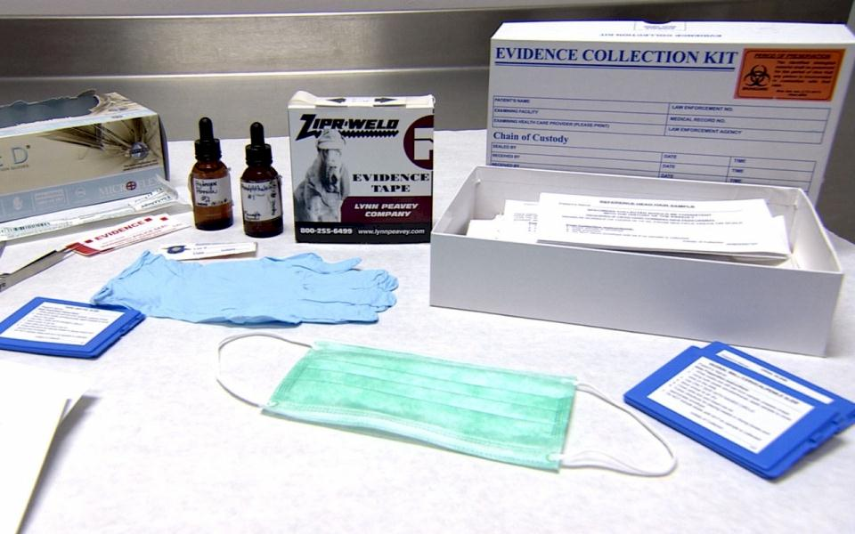

IMPORTANT REMINDER – This does not initiate a criminal proceeding.
The most important aspect of such a proceeding is your willingness to testify
and to provide whatever information may or may not be available about other witnesses.

Please take the time to check the information you have supplied to ensure it is complete and accurate.

Date questionnaire completed: .....................................................................................................................................
Please submit to person in attendance once completed.

Email to: rinj@rinj.org
Or war-crimes@rinj.net

